Project 60 CiviSDD Processes

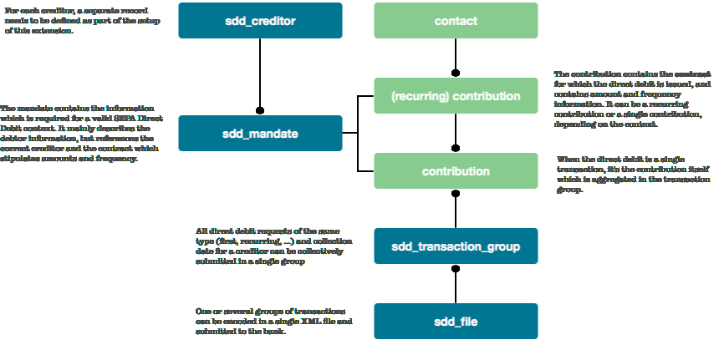
The physical data model will be established as the logical model is discussed and reviewed by the implementation team.

Processes
xxx
Process | Description
mandate.import | Take input from an external data source and create the mandate/contact structure in the database
mandate.prenotify | If needed, do the prenotification step
mandate.first

* indicates 'if present in DS-01' which is the materialized mandate.

The relationship to the contract record is defined by two attributes, one containing the ID and another containing the entity type. The different choices here are (currently) contribution or recurring contribution :

Group | Mandate attribute name | Attribute # | Represented as
Contract | Contract entity ID |  | int
Contract | Contract entity type |  | string

civicrm_sdd_creditor
This record is used to define individual creditor identities, which makes it possible to manage multiple creditors in a single CiviCRM install, or manage different sub-identities (possible using the same creditor id) inside a single organization.

This information will be stored in the civicrm_sdd_creditor record. As a consequence, the SDD creditor data cannot be changed once there is a mandate registered to it (referential integrity).

Attribute name | Attribute # | Represented as
The identifier of the Creditor | 02 | string 35
The name of the Creditor | 03 | string 70
The address of the Creditor | 05 | two strings (address lines 1 and 2)
Creditor IBAN |  | string 34
Creditor BIC |  | string 11

The identifier of the Creditor conforms to ISO 20022 data element ‘Creditor Scheme Identification’ :
- Positions 1 and 2 contain the ISO country code
- Positions 3 and 4 contain the check digits
- Positions 5 to 7 contain the Creditor Business Code. When the Creditor Business Code is not used, then the value is set to ‘ZZZ’
- Positions 8 up to 35 contain the country-specific identifier

The generated XML also contains the 'Category purpose of the Collection'. It is specified per payment, but I think it may be useful to add a general category purpose in the creditor record, which could be overridden per contribution (aka. contract).

In this release, we'll keep some additional information in the creditor record as well. We're not sure whether this should go into a config file or become a separate entity, but in all likelihood, this approach will work for 95% of the users.

Attribute name | Attribute # | Represented as
The Initiating Party Name |  | string 70
The Initiating Party Identification type |  | one of 'BICOrBEI', 'Other' or 'None' (in which case only name is used)
The Initiating Party Identification BICOrBEI value |  | string
The Initiating Party Identification Other ID value |  | string

For instance, in Belgium, the type is Other and the Issuer is KBO-BCE. Here, the XML snippet to use will be
<InitgPty>
<Id>
<OrgId>
<Othr>
<Id>0123456789</Id>
<Issr>KBO-BCE</Issr>
</Othr>
</OrgId>
</Id>
</InitgPty>

Other :

Attribute name | Attribute # | Represented as
Batch Booking  This functionality would allow the creator of the file to define for each file or even for each batch within a file, if it would be credited globally or individually on the ordering account.It is not generally supported by banks. |  | boolean
Mandate numbering prefix
Default value for Category purpose of the Collection | 59

civicrm_sdd_transaction_group
In order to prepare an XML file to send to the bank, it is necessary to group individual debit requests based on
- sequence type (first, recurring, one-off, final)
- collection date
- creditor (in case multiple creditors are used).

The standard civicrm_batch entity lacks the required fields to represent these parameters, so we propose to add a transaction batch 'header' object as follows :

Attribute name | Represented as
Unique reference | string
Sequence type | string 4
Collection date | date
Creditor ID | FK to sdd_creditor
Batch ID | FK to civicrm_batch

and aggregate the transactions using the civicrm_batch entity as follows :

civicrm_batch.name | Variable name/programmatic handle for this batch  Unique reference
civicrm_batch.title | Friendly Name  Human readable description of the batch
civicrm_batch.description | Description of this batch set
civicrm_batch.created_date | When was this item created
civicrm_batch.status_id | fk to Batch Status options in civicrm_option_values
civicrm_batch.type_id | fk to Batch Type options in civicrm_option_values  Needs a type 'SDD Transaction group'
civicrm_batch.total | Total amount for this batch
civicrm_batch.item_count | Number of items in a batch.  Not really used for the XML, could be the number of Payment Information blocks present
civicrm_batch.payment_instrument_id | fk to Payment Instrument options in civicrm_option_values

and the civicrm_entity_batch table :

civicrm_entity_batch.entity_table | physical tablename for entity being joined to file, e.g. civicrm_contact  would be civicrm_contribution for the SDD transaction batch record
civicrm_entity_batch.entity_id | FK to entity table specified in entity_table column
civicrm_entity_batch.batch_id | FK to civicrm_batch

There is no field in civicrm_batch to allow for the link back to the civicrm_sdd_transaction_batch ... perhaps the saved_search_id could be (ab)used ?

civicrm_sdd_file
This entity describes a set of batches to be sent in a single XML file to the collecting bank for the SDD creditor.

Attribute name | Represented as
Unique reference | string
Creation date | datetime
Transaction count | int
Transaction sum | decimal

Given its structure, we can implement this using the existing civicrm_batch entity :

civicrm_batch.name | Variable name/programmatic handle for this batch  Unique reference
civicrm_batch.title | Friendly Name  Human readable description of the batch
civicrm_batch.description | Description of this batch set
civicrm_batch.created_date | When was this item created
civicrm_batch.status_id | fk to Batch Status options in civicrm_option_values
civicrm_batch.type_id | fk to Batch Type options in civicrm_option_values  Needs a type 'SDD File'
civicrm_batch.total | Total amount for this batch
civicrm_batch.item_count | Number of items in a batch.  Not really used for the XML, could be the number of Payment Information blocks present
civicrm_batch.payment_instrument_id | fk to Payment Instrument options in civicrm_option_values

and the civicrm_entity_batch table :

civicrm_entity_batch.entity_table | physical tablename for entity being joined to file, e.g. civicrm_contact  would be civicrm_sdd_transaction_batch for the SDD file record
civicrm_entity_batch.entity_id | FK to entity table specified in entity_table column
civicrm_entity_batch.batch_id | FK to civicrm_batch

The list of Category Purpose codes is maintained at ISO 20022 level. It can be found at http://www.iso20022.org/

